T5 Bridgeplate Test Cable

The intent of this cable is to test rebuilt bridge plates from an active car. This means due to door closing you will be stretching the cable from a door operator across the inside of a car to the opposite open door. This prevents the door from closing on the cable in use.

PARTS

1. 14-16 ft of 16 GA wire, Use Tefzel wire and not Exane wire. The insulation on exane is twice as thick as tefzel.
2. Carside plug
   1. Manufacturer pn
   2. Trimet pn
3. 16 Pins for carside plug
   1. Trimet pn 245-XXXXx
4. Bp side plug
   1. Spacecraft SCPBH08PIVG22-14S-F0(U297)
5. 16 Pins for bp side plug
   1. Trimet 245-2112X
6. 16 wire labels cut in half
7. Cable wrap or shrink wrap DR-25
   1. https://www.digikey.com/en/products/detail/te-connectivity-raychem-cable-protection/DR-25-TW-3-4-0-SP/5317580
   2. https://www.digikey.com/en/products/detail/te-connectivity-aerospace-defense-and-marine/DR-25-3-4-0-SP/2397038

Tools required

* 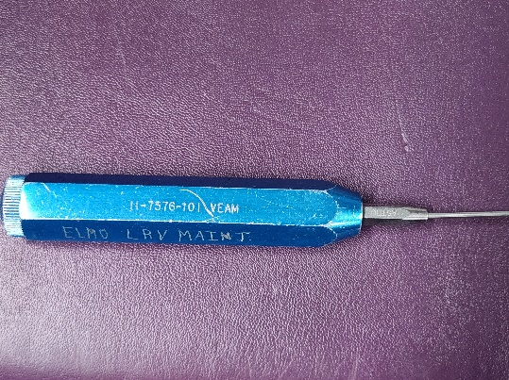DMC AF8 crimper
* VEAM 11-7576-101 pin removal tool
* VEAM 11-7345 pin install tool

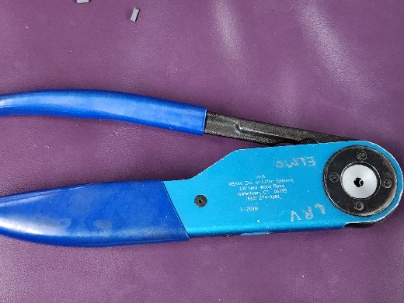

Assembly

1. Pull wires
2. Label wires
3. Assemble one plug end
4. Sheeth cable
5. Assemble the other end
6. Test cable

Pinout

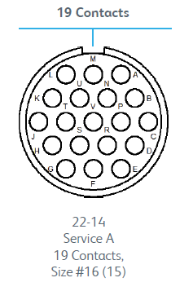

Figure : controller side connector pin arrangement

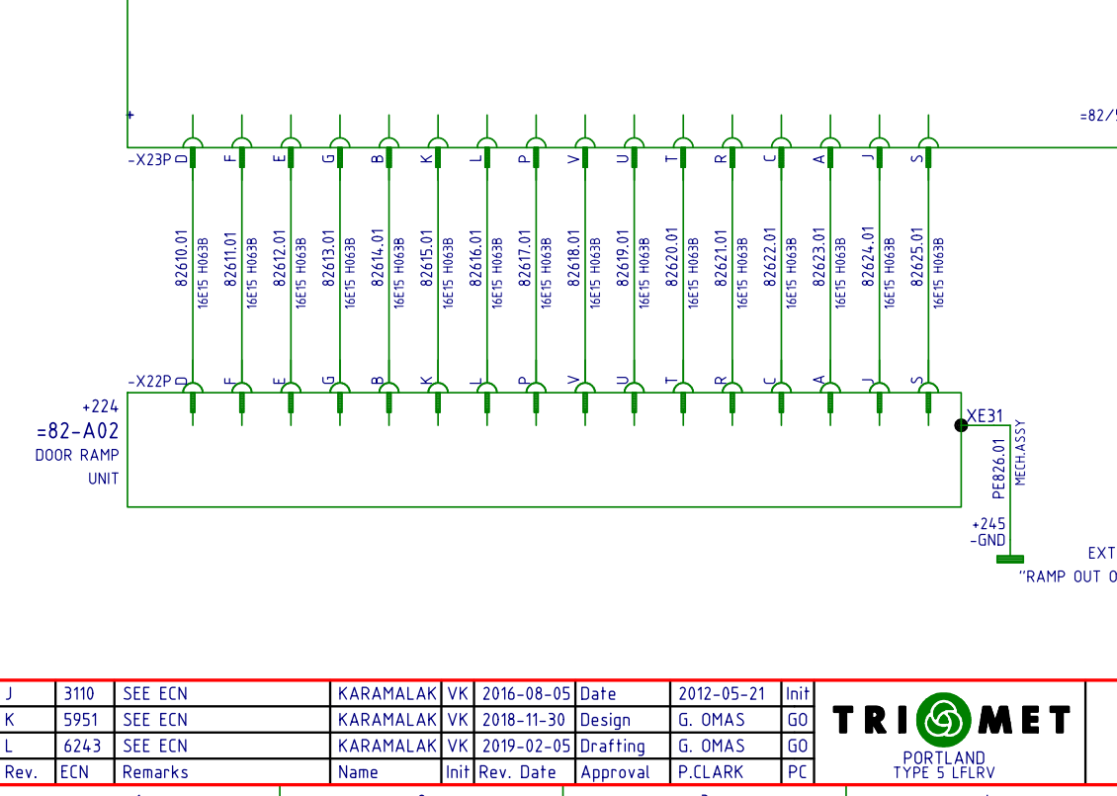

Figure : wiring schematic